Atlantis 5
  - User manual

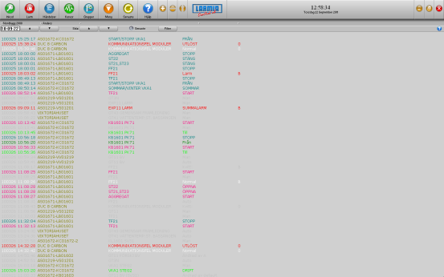
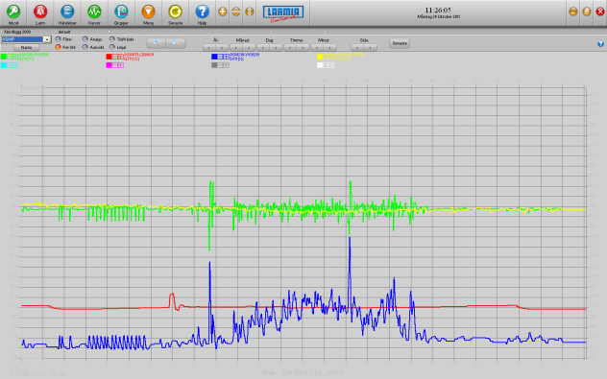
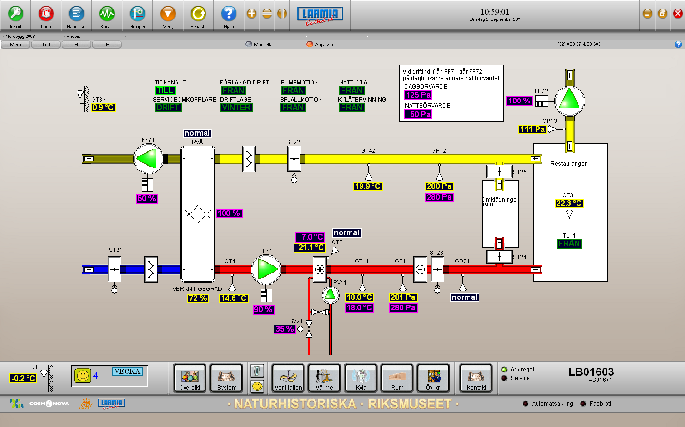

ANSVARSBEGRÄNSNING
All information i denna handbok har kontrollerats noggrant och bedöms vara korrekt. Emellertid lämnar Larmia Control AB inga garantier vad gäller manualens innehåll. Användare av denna manual ombeds rapportera felaktigheter, tvetydigheter eller oklarheter till Larmia Control AB, för eventuella korrigeringar i framtida utgåvor. Informationen i denna handbok kan ändras utan föregående meddelanden.

Mjukvaran som beskrivs i handboken levereras under licens från Larmia Control AB och får endast användas eller kopieras enligt licensvillkoren. Ingen del av denna bok får återges eller överföras i någon form eller på något sätt, elektroniskt eller mekaniskt, för något som helst ändamål utan uttryckligt skriftligt medgivande från Larmia Control AB.

COPYRIGHT
© Larmia Control AB. Med ensamrätt.
VARUMÄRKEN
MS-DOS, Windows, Windows 98, Windows NT, Windows 2000, Windows XP, Windows Vista och Windows 7 är registrerade varumärken som tillhör Microsoft Corporation.

Andra produktnamn som förekommer i denna bok används enbart i identifieringssyfte och kan vara ägarens registrerade varumärken.

DISCLAIMER
The information in this manual has been carefully checked and is believed to be correct. Larmia Control AB however, makes no warranties as regards the contents of this manual and users are requested to report errors, discrepancies or ambiguities to Larmia Control AB, so that corrections may be made in future editions. The information in this handbook is subject to change without prior notification.

The software described in this book is supplied under licence by Larmia Control AB and may be used or copied only in accordance with the terms of the licence. No part of this book may be reproduced or transmitted in any form, in any fashion, electronically or mechanically, without the express, written permission of Larmia Control AB.

COPYRIGHT
© Larmia Control AB. All rights reserved.

TRADEMARKS
MS-DOS, Windows, Windows 98, Windows NT, Windows 2000, Windows XP, Windows Vista and Windows 7 are registered trademarks of Microsoft Corporation.

Some product names mentioned in this book are used for identification purposes only and may be the registered trademarks of their respective companies.

November 2011
Revision: 1.0.0

Contents
Basics 1
Log In 1
The function keys 2
Objects 3
What is an Object? 3
The menu for objects 5
Analog In / Measurement 6
Analog Out / Setpoint 8
Indication 10
Alarm 11
Manoeuvre (Digital Control) 13
Status of manoeuvre and indication 14
Pulse 15
Control Curve 16
Settings of a control curve 17
Groups 19
What is a Group? 19
Select group (graphical- or text-based key diagram) 19
Menu for the group 20
Alternative presentation of a group 21
Dial-up connections 23
Events 24
Event List 24
The filter window (for the Event List) 25
Alarms 27
Alarm List (existing alarms) 27
Alarm status 28
Acknowledge alarms 28
Trend Curves 29
Joint Trend Curves 29
Trend Curves 31
Trend Curves for single objects 33
Functions for Trend Curves 33
Picture editor 36
Display functions 36
The grid 36
Zoom 36
Run / Real mode 36
Object types 36
Text 37
Symbol / Picture 37
Figures 37
Overlapped page 37
Object properties 38
Visibility 38
Frame & Color 38
Snap to / Align mode 38
Object edit tools 39
The pointer 39
Edit 39
Special properties 40
Motion 40
Types 40
Page functions 40
Group / Page 40
Format 41
Archive 41
Keyboard commands 42
Files and folders 44
Time Schedules 46
Time Schedules 46
Editing of Time Schedules 47
Functions for the Time Schedule 49
Calendar 51
Editing 54
Edit (plant configuration) 54
Conditions (logic functions) 57
Loading of the program to the CCU 58
Misc. 60
To start and to quit 60
Configuration 62
The Control Panel 62
Regulators 62
Notes 64
The Calculator 64
Last choice 65
Help texts 65
Larmia Control 65
Window handling 65
Time and date 66

Basics

Log In
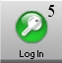
With this key function you can log in at a chosen level in the system. The selected level is shown with the number on the key. The level determines what permission the person has to execute different operations in the system. It includes operations like acknowledgement of alarms, control of operations, making and changing of drawings etc.
The function is also used when leaving and locking the system to make sure that no unauthorized person can start operating the computer, and when log in shall be done.
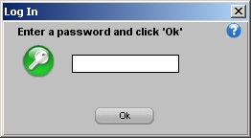
When the key is clicked a single dialog window is shown with a request to write your password. After that click the "OK"-key or push the "Enter"-key. The system has preset passwords to be able to authorize the administrator to the right level of control and operation.
The lowest level of authorization is level zero and doesn’t require a password, and the space for the password is then left empty. On the zero-level the system is considered locked, as nothing is permitted except checking the status of the plant. That is the same level as automatically is set when starting up the program. If the Window-program has a screensaver activated, the program goes automatically back to level zero when the screen is shut down.
Please note that the password makes a distinction between capital letters and lower-case letters, so if the password doesn’t work you should check that the "Caps Lock"-key is not activated

The function keys
Key | Description
F1 | Help texts for the selected function.
F2 | Silencing of alarm sound.
F12 | Choose the last selected group.
PRINT SCRN | Send picture of the screen to the printer (requires LCCapture).

Objects

What is an Object?
An object is a position in the system. The present status (condition) of the object is shown with text and colour. The object can be represented on the screen by a text or by a symbol, and by clicking the name of the object an information window shows up with information about the object, and different choices can be made to get more information about it. Clicking the ”Menu” makes changes of the settings of the object and editions-key among the main keys at the top of the screen.
Every object has an unique identification number to be recognized by the system. Normally it is not necessary for the user to remember the identification number that is done by the system itself but it is sometimes needed when referring to a single object. This happens almost only in system functions when setting up conditions and controls for other objects.
There are different types of objects depending on which signal the object is going to represent. The signal can be an input or an output and be of an analogue or a digital type. There are also other types depending on which signal the object shall represent.
The different types of objects are:
ALARMS: Objects, which are warning when supervised objects pass into an abnormal condition.
Flashing red/white | Remaining alarm which is not acknowledged.
Flashing grey/white | Cancelled alarm which is not acknowledged.
Permanent red | Acknowledged remaining alarm.
Permanent white | Normal (no alarm).
For further information about alarms, see section Alarm .

DIGITAL CONTROLS: Controllable objects with only two status, one active and one passive.
Light blue | On.
Dark blue | Off.
When conflict alarms are used and there is no indication within the delay time, the object will have the same colours as when an alarm from an alarm object.
Further information about digital controls you can find in section Manoeuvre (Digital Control).
INDICATIONS: Objects showing in which status, active or passive, the supervised object is.
Light green | On.
Dark green | Off.
For further information about indications, see section Indication.

PULSE VALUES: Objects with an input signal varying between a high and a low value, and counting each time the value is varying. The counter is used as a measure of consumption over a period of time.
Brown
For further information about analogue out, see section Pulse.

ANALOGUE IN and MEASUREMENTS: Objects with a variable incoming signal converted into a linear scale.
Yellow | Normal
When limit alarms are used and the limits are exceeded the object will have the same colours as when an alarm from an alarm object.
Further information about analogue in you can find in section Analog In / Measurement .

ANALOGUE OUT and SET POINTS: Objects with a variable outgoing signal which are setting the values from a linear scale.
Purple
For further information about analogue out, see sectionAnalog Out / Setpoint.

CURVES: Objects with a variable outgoing signal which is following a preset curve for different parameters.
Purple
For further information about curve objects, see section Control Curve.

The menu for objects
To the right in the information window for an object there is a key named "Menu", and by clicking that function a new window is showing up where You can choose other functions for the object. There are maximum four visible keys, and they are named Event List, Notes and Trend Curves respectively.

By clicking the key Event List the list of events for a specific object can be studied. A new main window is shown with an event list, which has the same appearance as the event list for the whole system. The list is dynamically updated and the events are assorted according to the times when they appeared into the system. The extra functions which you can find in the upper part of the window for choosing the date and filter are exactly the same as in the event list for the whole system. For more information about the functions for the event list, see section Event List .

For writing and reading information and notes concerning the object in question the key Notes is used. Then a new program is started and will be visible on the screen with functions for typing of text in a text editor. For further information about this, see section Notes.
The last key, Trend Curves, is only visible when the menu belong to an analog object. The different types of analog objects are analog outputs, set points, measured values, pulses or curves. Trend curves are used to have an easy overview of the changes for objects having a status, which is varying by the time. These changes are not visible in the event lists but are shown in a time-diagram. For further information about this, see section Trend Curves for single objects .

Analog In / Measurement
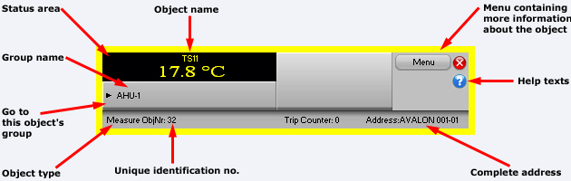

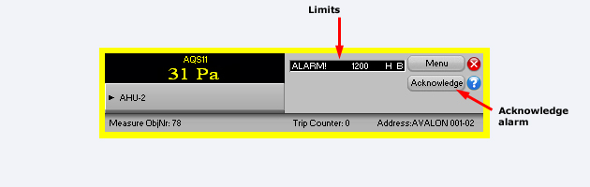
In the title at the top of the window is shown the type of object and the name of it.
In the black field to the left in the window you can see the present status of the object, the measured value and the unit. The other two narrow rectangular fields are only visible when there are alarm limits edited for the object. In these fields You can read the text describing the alarm limit, the alarm limit in figures followed by the unit and at last the priority class of the alarm.
For further information about the status of alarms, see section Alarm status.
The number, which you can read after OBJECT NO: above the black field, is the internal identification number of the object, which is used only as a reference of the object and control.
The number following ADDRESS: above the keys to the right is the complete address of the object. The shortening consisting of three letters indicates to which manufacture of the CCU the object is connected by means of hardware, and the following figures are the exact address formatted according to the address of the manufacture.
Below the black field to the left the group name of the object is shown. The key marked "->" to the left is a key for direct choice of the group, which means that if You click that key, the main window of the group to which the object belongs will be visible on the screen.
By clicking the key Menu in the upper right corner of the window You will see a menu from where You can get additional information about the object, as logging of the values or notes regarding the object.
For further information about the menu, see section The menu for objects .
Below the key Menu You can see another key Ack, if the object has an unacknowledged status. This key is used when acknowledging an alarm.
Further information about acknowledging of alarms, see section Acknowledge alarms.
For removing of the window, the Window functions to the very upper left of the window are used.

Analog Out / Setpoint
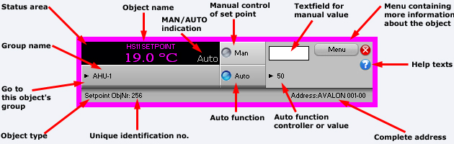
In the title at the top of the window is shown the type of object and the name of it.
In the black field to the left in the window you can see the present status of the object, the measured value and the unit. To the right in the black field You can see in grey text the present control position, either "MAN" when using manual control or "AUTO" when using automatic control. When using manual control the object is controlled with a constant value from a computer or a CCU, not from a main switch. When using automatic control a computer or a CCU is controlling the regulation of the object with the condition, regulator or object relation, which is edited for the object.
The number, which you can read after OBJECT NO: above the black field, is the internal identification number of the object, which is used only as a reference of the object and control.
The number following ADDRESS: above the keys to the right is the complete address of the object. The shortening consisting of three letters indicates to which manufacture of the CCU the object is connected by means of hardware, and the following figures are the exact address formatted according to the address of the manufacture.
Below the black field to the left the group name of the object is shown. The key marked "->" to the left is a key for direct choice of the group, which means that if You click that key, the main window of the group to which the object belongs will be visible on the screen.
By clicking the key Menu in the upper right corner of the window You will see a menu from where You can get additional information about the object, as logging of the values or notes regarding the object.
For further information about the menu, see section The menu for objects.
The key Man and the following editing field in the right part of the window, is used for manual control of the setting. For setting of a value manually for analogue out, you start by typing a value (either with or without decimals) in the editing field. After that you click the Man key for transferring of the value. The chosen value will remain until another setting is done or until turning over to automatic control.
The key Auto in the lower part of the window is used for the setting in automatic operation. The text to the right of the key is informing about which value, object or system function that is controlling the object during automatic operation.
For removing of the window, the Window functions to the very upper left of the window are used.

Indication
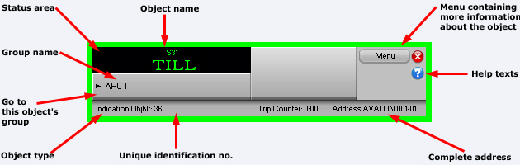
In the title at the top of the window is shown the type of object and the name of it.
In the black field to the left in the window you can see the present status of the object, text for indication on or off.
For further information about the status of indications, see section Status of manoeuvre and indication .
The number, which you can read after OBJECT NO: above the black field, is the internal identification number of the object, which is used only as a reference of the object and control.
The number following ADDRESS: above the keys to the right is the complete address of the object. The shortening consisting of three letters indicates to which manufacture of the CCU the object is connected by means of hardware, and the following figures are the exact address formatted according to the address of the manufacture.
Below the black field to the left the group name of the object is shown. The key marked "->" to the left is a key for direct choice of the group, which means that if You click that key, the main window of the group to which the object belongs will be visible on the screen.
By clicking the key Menu in the upper right corner of the window You will see a menu from where You can get additional information about the object, as events or notes regarding the object.
For further information about the menu, see section The menu for objects.
For removing of the window, the Window functions to the very upper left of the window are used.

Alarm
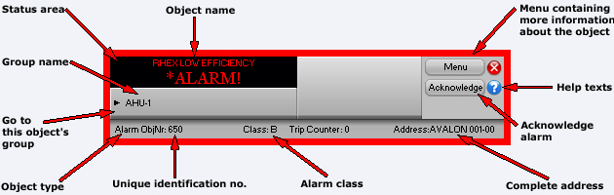
In the title at the top of the window the type and name of the object are shown.
In the black field to the left you can see the present status of the object, the normal text or the alarm text if there is an alarm.
For further information about the status of alarms, see section Alarm status.
The number following OBJECT NO: above the black field is the internal identification number of the object. This number is only used as a reference of the object and control.
The number following ADDRESS: above the keys to the right is the complete address of the object. The shortening consisting of three letters indicates to which manufacture of the CCU the object is connected by means of hardware, and the following figures are the exact address formatted according to the address of the manufacture.
Below the black field to the left the group name of the object is shown. The key marked "->" to the left is a key for direct choice of the group, which means that if You click that key, the main window of the group to which the object belongs will be visible on the screen.
To the right of the group name you will find an extra key marked XtraTxt, if any extra text is edited for the object. The key is used for showing an extra alarm text for the object with a simple text editor. For example if a special routine has to be performed when there is an alarm from the object, and there is not space enough for the text in the black field.
By clicking the key Menu in the upper right corner of the window You will see a menu from where You can get additional information about the object, as events or notes regarding the object. For further information about the menu, see section The menu for objects.
The key Ack to the right in the window is used for acknowledgement of the alarm of an object, which is still not acknowledged. Even if the alarm is cancelled, the object has to be acknowledged to return to normal status.
When the object is acknowledged, the key disappears and will not be visible until there is a new alarm for the object. Further information about acknowledgement you will find in section Acknowledge alarms.

Manoeuvre (Digital Control)
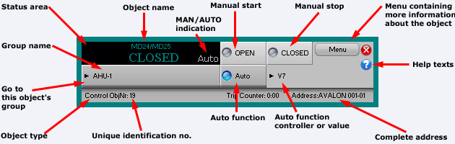

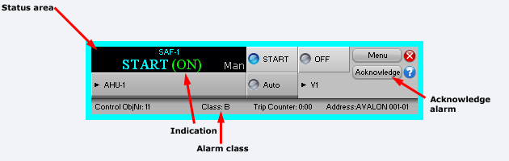
In the title at the top of the window is shown the type of object and the name of it.
In the black field to the left in the window you can see the present status of the object. If the object also has a direct connected indication, the status of the indication follows within parenthesis.
To the right in the black field You can see in grey text the present control position, either "Man" when using manual control or "Auto" when using automatic control. When using manual control the object is controlled with a constant value from a computer or a CCU, not from a main switch. When using automatic control a computer or a CCU is controlling the regulation of the object with the condition, time schedule or object relation, which is edited for the object.
For further information about the status of manoeuvres, see section Status of manoeuvre and indication.
The number which you can read after OBJECT NO: above the black field is the internal identification number of the object, which is used only as a reference of the object and control.
The number following ADDRESS: above the keys to the right is the complete address of the object. The shortening consisting of three letters indicates to which manufacture of the CCU the object is connected by means of hardware, and the following figures are the exact address formatted according to the address of the manufacture.
Below the black field to the left the group name of the object is shown. The key marked "->" to the left is a key for direct choice of the group, which means that if You click that key, the main window of the group to which the object belongs will be visible on the screen.
By clicking the key Menu in the upper right corner of the window You will see a menu from where You can get additional information about the object, as events or notes regarding the object.
For further information about the menu, see section The menu for objects.
The keys ON and OFF in the right part of the window are intended for manual operation of the manoeuvres. The selected manoeuvre will remain until another one is chosen. Note that a forced stop has a higher priority than manual manoeuvres, and that manual operation doesn't control the manoeuvres as long as the forced stop is active.
The key Auto in the lower part of the window is used for changing over to automatic operation. The text to the right of the key is informing about which object or system function that is controlling the object during automatic operation.
For removing of the window, the Window functions to the very upper left of the window are used.

Status of manoeuvre and indication
The status of the manoeuvre of the object is shown by text and color.
Object type | Status | Color
MANOEUVRE: | On | Light blue
 | Off | Dark blue
INDICATION: | On | Light green
 | Off | Dark green

Pulse
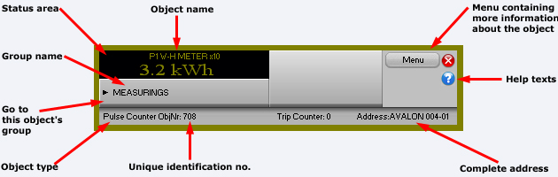
In the title at the top of the window is shown the type of object and the name of it.
In the black field to the left in the window you can see the present status of the object, the measured value and the unit.
The number, which you can read after OBJECT NO: above the black field, is the internal identification number of the object, which is used only as a reference of the object and control.
The number following ADDRESS: above the keys to the right is the complete address of the object. The shortening consisting of three letters indicates to which manufacture of the CCU the object is connected by means of hardware, and the following figures are the exact address formatted according to the address of the manufacture.
Below the black field to the left the group name of the object is shown. The key marked "->" to the left is a key for direct choice of the group, which means that if You click that key, the main window of the group to which the object belongs will be visible on the screen.
By clicking the key Menu in the upper right corner of the window You will see a menu from where You can get additional information about the object, as logging of the values or notes regarding the object.
For further information about the menu, see section The menu for objects.
For removing of the window, the Window functions to the very upper left of the window are used.

Control Curve
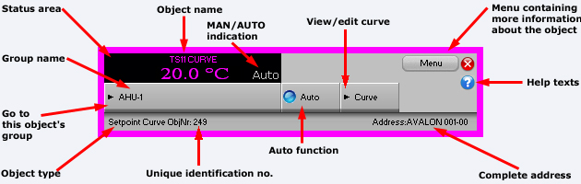
In the title at the top of the window is shown the type of object and the name of it.
In the black field to the left in the window you can see the present status of the object, the measured value and the unit. To the right in the black field you can see the present control position in grey text. For curve objects there is always the text "Auto", as manual control of curve objects is not relevant.
The number, which you can read after OBJECT NO: above the black field, is the internal identification number of the object, which is used only as a reference of the object and control.
The number following ADDRESS: above the keys to the right is the complete address of the object. The shortening consisting of three letters indicates to which manufacture of the CCU the object is connected by means of hardware, and the following figures are the exact address formatted according to the address of the manufacture.
Below the black field to the left the group name of the object is shown. The key marked "->" to the left is a key for direct choice of the group, which means that if You click that key, the main window of the group to which the object belongs will be visible on the screen.
By clicking the key Menu in the upper right corner of the window You will see a menu from where You can get additional information about the object, as logging of the values or notes regarding the object.
For further information about the menu, see section The menu for objects.
The key Auto in the lower part of the window is used for the setting in automatic operation. The text to the right of the key is informing about which system function that is controlling the object during automatic operation.
The key "->" in the lower right part of the information window is the key for changing of the setting of break points and gradient of the curve. More information about this you can find in section Settings of a control curve.
For removing of the window, the Window functions to the very upper left of the window are used.

Settings of a control curve
To change the gradient and the breakpoints of a curve object graphically, the key "->" in the lower right part of the window for a control curve is used. When clicking this key a new window shows up, showing the present curve in a diagram with the limit values and breakpoints which are edited for the object.
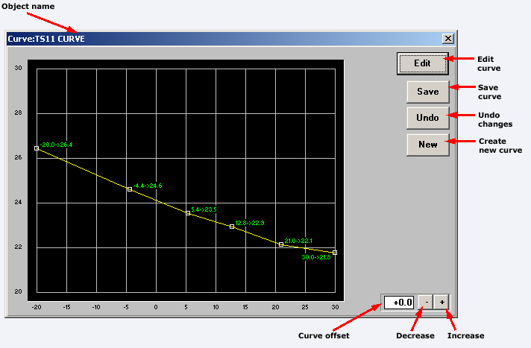
Originally the window consists of a black field with a diagram to the left, a key named Edit in the upper right corner and a field for editing below to the right.
In the diagram you can see the present edition of the curve with breakpoints and limit values for different X and Y values. The curve has a yellow colour, and the changable break- and limit values are marked with white squares placed on the curve. Next to the squares you can read the exact X and Y coordinates for the break- and limit points in green colour.
The diagram is covering the area within the limits of the edition. To increase the area you have to choose new values for the limits in the editing function. For more information about editing of objects, see section Editing.
To change the position of the breakpoints, end values and gradient of the curve, you have to click the editing key. When doing this another three keys show up below the Edit key, and also two keys to the right of the editing field in the lower right corner of the window. The shape of the curve is changed by clicking the mouse on one of the white squares of the break- or limit points, keep the key of the mouse pressed down and move the mouse marker to the new position. This procedure has to be repeated until the shape of the curve is to your satisfaction, and after that you click the key Save to the right in the window. If you regret, and want to keep the original shape of the curve which you had at the last saving or when the window of control curves appeared, then you click the key Cancel.
There is also a possibility to transfer the whole curve upwards or downwards. For this purpose You are using the two keys to the very right below and the editing field to the left of the keys.
To transfer the whole curve one unit upwards you click once on the key to the right marked "+". That will be marked in the editing field as the figure shown there will be increased by one unit, but the curve in the diagram will stay in the same position. To lower the whole curve one unit you click the left key marked "-" once. That will be marked in the editing field as the shown figure will decrease by one unit, but the curve in the diagram will stay in the same position. You can also click the editing field directly and type the wanted value.
When the wanted values for the transferring of the curve are set, You can either choose the key Save for saving of the settings, or the key Cancel if You want to keep the values which were set before the last saving or when the window of control curves appeared. When the changes are done the CCU has to be restarted. See section Loading of the program to the CCU.

Groups

What is a Group?
All objects are divided into groups, where a group normally consists of a building, a ventilation room, a sub central, a drawing of the process or a group of objects with similar assignment.
A group is selected by clicking the main key Select Group. All the groups in the system will then be shown in graphical- or text-mode (in alphabetical order) in the window. Click the name of the group, and the group will show up.
You can also directly find the group, which an object belongs to by clicking the name of the object. Then the window with the object information will show up, and by clicking the arrow you will automatically reach the group of the object.

Select group (graphical- or text-based key diagram)
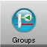
With this key function a separate window is shown where all the groups in the system are presented. Choose the wanted group by clicking the mouse on the group, and a new main window is coming up showing all the objects in the group, presented with a picture if there is any.
When the window showing all the objects in the group is visible, there are also some additional functions to choose at the top of the group window. To the very left you will find the key Menu. When clicking this key you will see a menu, from where you can have additional information about the group, for example events and notes, or design a drawing and show graphical objects of the group.
Additional information about the menu you will find in the section Menu for the group.
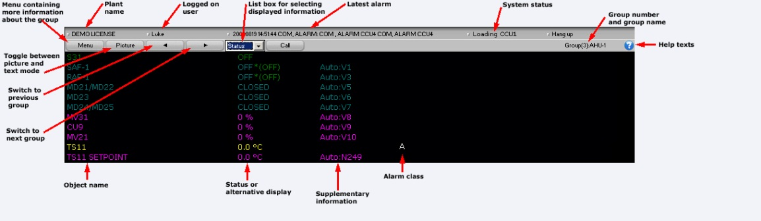
The next key is named Picture or Text, and with this key you can choose between having a schematic picture showing how the objects in the group are connected to each other, or just to see the objects listed in writing in the window. The name of the key is alternating into "Picture" when the objects are presented in a list, and into "Text" when the objects are shown in a picture. When choosing a presentation by text there is more information about each object than in a picture.
With the two keys marked with arrows ("<-" and "-> ") you can quickly navigate from one group to another in the system, in alphabetical order.
The next extra function you will find is a text with an arrow to the right. By this function you can choose alternative presentations of the information about the objects in the group. The alternatives you can find in a list box by clicking the arrow. More information about alternative presentation you will find in the section Alternative presentation of a group.
If any object in the group is connected to a CCU by a dialing up modem, there are additional functions in the key bar at the top of the main window. See section Dial-up connections for more information about the functions for dialing up CCU.

Menu for the group
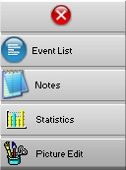
To the upper left in the main window for a group you find the key Menu. By clicking that key a new window will show up containing four keys with functions for the groups. By using the first key you can look at the event list for the objects only within one group, and the next key gives you a window for notes where you can write and read information regarding the group. By clicking the third key you will have statistics for the objects in the group, and the last key is for editing of dynamics and designing of drawings for the group.
The event list for objects belonging to one and the same group appears when clicking the key Event List. This main window with the event list looks the same as the event list for the whole system. The list is dynamically updated and the events are assorted according to the times when the events were registered. The additional functions at the upper part of the window for selecting of the date and filter are exactly the same as for the event list for the whole system. For more information about the functions for the event list, see section Event List.
To have the possibility to write and read information and notes about the group you choose the key Notes. Then a new program is started with functions for typing of text in a text editor. For more information about how to write information, see section Notes.
If you want to make a schematic drawing etc. for the group and to change the position of the dynamics, you choose the key Picture Edit. When this key is clicked more keys with more functions will be visible in the main window of the group. One of these keys gives you support about how to place new dynamics and how to place dynamics as symbols. More information about the functions of the keys, see section Picture editor.
If you regret and want to remove the choice in the menu, the Window functions to the upper left in the menu window are used.

Alternative presentation of a group
In the middle of the upper part of the window there is a list box. Click the arrow to the right of the text and choose the type of information, which you want to be shown on the main window of the group.
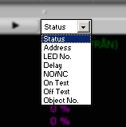
• If you choose Status every object in the window will be presented with the present status, by showing the status text, which is edited to the status positions. This is the normal operation situation.
• If you choose Address the complete address for every object in the window will be shown, starting with a shortening consisting of three letters showing to which manufacture of the CCU the object is connected concerning hardware. The following figures are the exact address number formatted according to the address of the manufacture.
• If You choose LED Number every connection of the objects to the LED:s on the front of the CCU will be shown in the group window. To which CCU the object is connected is shown by it’s address. (Only valid for Larmia Control CCU LS920).
• If you choose Delay the delay of every object will be shown in the window of the group. The delay relates to the time in minutes and seconds before activation after a change of the status, and refers to the delay within the PC. (For objects belonging to the Larmia Control DUC LS920 there is no delay within the PC but refers to the delay within the CCU).
• If You choose NO/NC every object is showing its activation at either a closing or breaking input with NO (Normal Open) for activation when there is a closing at the input and with –NC (Normal Closed) for activation when there is a break at the input. The minus sign in front of NC has no formal significance but is only for better clearness. (For objects belonging to other CCU-manufactures than LS920, the function, which is edited for the object, is valid – there is no connection to or control of the object at the CCU showing if the object is wrongly edited).
• If you choose Text On the text for every activation-position of the digital objects will be shown in the window of the group, and for alarm objects the alarm texts will be shown. This doesn’t concern the analogue objects if they don’t have alarm limits edited.
• If you choose Text Off the text for every deactivation-position of the digital objects will be shown in the window of the group, and for alarm objects the normal positions will be shown. This doesn’t concern analogue objects.
• If you choose Object Number the individual index number of the object will be shown in the window of the group. This index number is mainly used when referring to other objects in system-functions and conditions. For more information, see section System Functions.
The system returns to show "STATUS" after the screen saver has been activated. This happens automatically without any keyboard instruction.

Dial-up connections
A connection between the SCADA and the CCU can be of two types when a modem and a telephone line is used. The connection can be permanent or configured in a way that the CCU will dial up at certain occasions. This is called to have a Dial-up connection, and is mostly configured so that the CCU is calling up the SCADA when an alarm is activated. Connection with the SCADA can also be requested in order to pick up information and change settings.
When the main window shows a group with an object belonging to a CCU, which is connected, with the SCADA by a dial-up modem, there is another button available at the upper part of the main window.

To dial the CCU simply click on Call. When a connection is established the text on the button will change to Hang Up. To disconnect, simply click this button.
The connection is established with a preset time of 300 seconds. If the time of connection begins to run short, click Extend Time to extend the time with another 300 seconds. This function can be utilized several times until the needed maximum time of connection is reached.
The remaining time of the connection to the CCU is shown in the status bar of the window, and is counted down until disconnection.

Events

Event List

With this key function a window is shown with a list of all the events in the system. The list is dynamically updated and the events are sorted according to the time when they were registered by the SCADA, while the time is set when the event was registered by the CCU.
Except for the functions at the very top of the event list, the content has the same functions as a normal group window. If You click the line for a single object a small window is shown with further object information, where You among other things can go on to the objects home group or manually control the object.
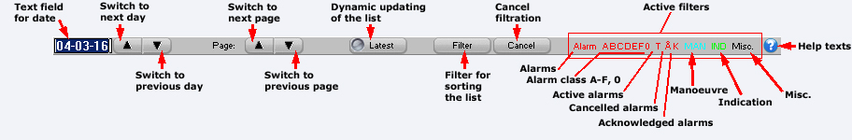
At the very upper left is an editing field showing the date from which the list will start showing events. In this field you can choose another date to be able to see the events on that date. Today’s events are normally always shown. Click the editing field, write the desired day and click the "Enter"-key. The list for the chosen date is now shown.
On the right side of the editing field is a "-" and a "+"- key. With these keys you can quickly go one day backwards or forwards without changing the date in the editing field.
The next group of functions at the very top of the window are the "Page"-key and another "-" and "+" -key. With these keys you can go backwards or forwards one page to look at the events. When doing this the date in the editing field to the left is also changed.
In the middle upper part you can read Latest with a marking-square to the left. If you click on the text or in the square you are marking if the presentation shall be dynamically updated or not. This means that if a new event is coming into the system, the event will be added to the list and automatically shown, even if you for the moment are looking at another page. If you don’t have the "Latest" marked you will not observe when a new event appears. The events will of course be registered anyways so that no events are lost but will be shown when "Latest" is marked again, or when the event list is viewed next time.
The Filter key to the very upper right of the window is used for filtering of events from the event list. For more information about filtering of events, see section The filter window (for the Event List).
The key Abort search to the very upper right in the window is only shown when the database is searched through for new events to show. Searching in the database can sometimes take longer time- especially when filtering is used – and can with this function be stopped when the wanted information is already shown. When the searching has been stopped or is ready, new functions can be chosen.
To remove the window the Window-function at the very upper left corner is used.

The filter window (for the Event List)
This window is shown when choosing the Filter key when looking at the event list. In the window You will find functions to filter special events from the list. It is only the viewed events which are filtered, and no matter how the filtering is done, no events will be erased from the system. All events can be seen again as soon as the filtering is interrupted.
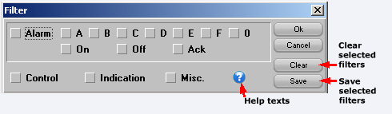
By clicking the Alarm key, all events concerning alarms are filtered from the event list. There are different numbered squares for marking, if You only want to filter alarms with certain priority.
• When marking the square for Alarm all events concerning alarms are filtered.
• When marking the square for On all activations of alarms are filtered from the event list.
• When marking the square for Return all cancelled alarms are filtered from the event list.
• When marking the square for Ack all acknowledgements of alarms are filtered from the event list.
• When marking the squares for A - 0 all events concerning alarms with the corresponding priority are filtered from the event list.
Below the field for filtering of alarms there are another three squares for marking where You can filter other events, and two keys.
• When marking the square for Man all events concerning on/off-control of digital objects are filtered from the event list.
• When marking the square for Ind all events concerning on/off-control of indications of objects are filtered from the event list.
• When marking the square for Misc all other events are filtered from the event list, for instance system events as logging in and print out.
When clicking the key Reset all the markings in the squares in the field for filtering are removed, and all events in the event list are shown again.
When clicking the key Save all existing markings and settings are saved, and next time when the event list is shown the settings will be intact and the same type of events will be filtered.
The keys Ok and Cancel executes respectively cancels the changes which are chosen, and remove the filter window.
To remove the window the Window-function at the very upper left corner is used

Alarms

Alarm List (existing alarms)
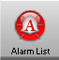
When clicking this key function a window is shown with all the existing alarms in the system. The list is updated dynamically and the alarms are assorted according to priority. The key is also changing appearance when new alarms are entering the system, as the key with red text is showing the alarm with the highest priority of the alarms still not acknowledged. This gives the possibility of a quick observation when a new alarm is coming into the system.
Except from the extra functions at the very top of the alarm list window, the contents have the same functions as a window for a normal group. When clicking on the line for a single object a small window is shown with further object information, where You among other things can proceed to the home group of the object or acknowledge the object . See the section about Select group (graphical- or text-based key diagram) for more information about these functions
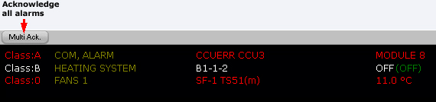
At the very top at the left of the window is the key "Multi Ack". With this key you can acknowledge all present unreset alarms in the system, the active alarms as well as the previous alarms.
Further information about acknowledgement of alarms, see section Acknowledgement of alarms.
When the configuration is set to give an alarm signal when a new alarm appears into the system, You stop the alarm sound with the key "Silence". The sound can also be stopped by acknowledging the object or by pushing the "F2"-key on the keyboard.
To remove the window the Window-function at the very upper left corner is used.

Alarm status
The alarm status of an object is shown by text and color.
Alarm status | Color | Priority
Unacknowledged remaining alarm | Flashing red/white | Highest
Unacknowledged cancelled alarm | Flashing grey/white
Remaining alarm | Permanent red
Normal | The normal color of the object | Lowest

Acknowledge alarms
To acknowledge an alarm signal you choose the main key Alarm List and then click the key Silence.
For acknowledgement of a single alarm you choose the object, which shall be acknowledged by clicking the text of the name of the object. After that you click the key Ack. When the object is acknowledged the key disappears and will not be visible until there is a new alarm for the object.
For acknowledgement of all the alarms in the system you choose the main key Alarm List and after that the key Multi Ack.
If the system is configurated to use signatures for acknowledgement, a simple editing window will show up and request the user to write his signature. If the signature is not approved for acknowledging of the object, the object will remain unacknowledged and a sound signal can be heard from the computer.

Trend Curves

Joint Trend Curves

When choosing the key Trend Curves, on the speed bar at the top of the window in the operation program, a new main window is shown where it is possible to show several trend curves in the same diagram. This window differ from the window showing the trend curve for a specific object, as You here also have a list box and a key named Preferences to the upper right.
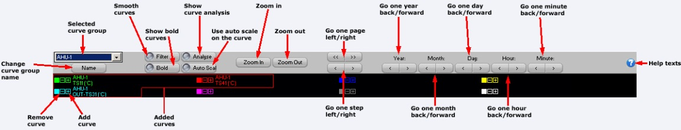
In the list box, which in the beginning is empty, different diagrams are collected, consisting of trend curves for a group of objects. When a diagram is made the title is shown in the list box, and by clicking the list box you can see the whole contents of it and you can choose one of the diagrams by clicking the title. This gives the possibility to collect several objects of the same type in different diagrams, and to view different types of trend curves for objects. For example the control of shunt valves for ventilation in different fan-rooms can be collected in one diagram, and the temperatures for supply air to different sections can be collected in another one.
When you have chosen a diagram, all curves belonging to it are shown in the window. To choose the objects, which shall be presented in the diagram, you click the key "Preferences" and a dialogue-window is shown for marking of the objects and the colours of the diagram.
The dialogue window consists of a space for editing of the title, three keys for the colours of the diagram, colours of the trend curves, two keys for adding or removing of objects, one square for marking if the trend curve shall be visible and three lines for object information. Below there is also a key named "Close" to save the changes and to remove the window.
In the space for "Title" the title of the present trend curves are entered. This is the title, which later on will be shown in the list box in the upper part of the diagram window when choosing a diagram.
With the three keys following "Colour" You can change the colours of the background of the diagram, the grid and the rectangle for zooming in respectively. If any of the keys is clicked the object will change colour. Go on clicking until the wanted existing colour appears.
There are eight different choices of colour for the trend curves in the diagram. By choosing one of the eight numbered keys you are choosing that colour for the specific object, which name is shown as the last one on the list shown in the window. Maximum eight trend curves can be shown in the same diagram.
With the key "Add selected object" a new object can be added to the diagram, or an existing connection between objects can be changed. To be able to add an object it must be an open information window for an analogue object visible on the screen. Such a window will open when an object is clicked in a group function window, and it will remain open until it will be closed by clicking the system function in the Window-programme to the upper left of the screen.
When the information-window of an object is open and the key "Add selected object" is clicked the object will be added to the diagram with the colour, which is chosen, from one of the numbered keys following "Curve" above. If the latest chosen colour already has been used for another object, that object will be erased before the new object will be added.
To remove the display of an object from the diagram the key for the colour of the object (one of the keys following "Curve") is clicked, and after that the key "Remove curve" is clicked. The display of the object disappears from the diagram and the colour can be used for another object.
The marking square "Show" is used if the trend curve of the chosen object shall be shown in the diagram or if it shall be temporarily hidden. To hide trend curves might be practical in order to show curves, which is difficult to visualize among other curves or to utilize the auto scale optimally.
Hint!
To add trend curves for objects in new diagrams it’s easier if You have two main windows open side by side. In one of the windows You can have the trend curves and in the other one You can change between groups to pick up objects. When the object that you want to add in the diagram is visible in the group window, You click it to make the information window for that object visible. After that You change to the window for the trend curves and choose the colour of the curve and click "Add selected object". If You want to add more objects You go back to the group window and pick up the next object etc.
To work with more than one main window open, see section Window handling.

Trend Curves
With this key function a window is shown with graphs representing trend curves for the objects. To use curves and diagrams to show the course of events and how the control has been executed for an object, is easy and comprehensibly. Furthermore it is a quick way for troubleshooting of the control of the objects, as there are possibilities of zooming the trend curves at different times.
The ATLANTIS SCADA software offers trend curves for all objects of analogue type - analogue in, analogue out, set points and measuring points – with the exception of curve objects. The course of events for digital- and pulse-objects can’t be visualized by trend curves of the operation program.
In the operation program there are two ways of viewing the trend curves for objects. There is a joint presentation where curves for several objects can be shown in the same diagram, or curves for a specific object can be shown separately. To show the trend curves for several objects you choose the key "Trend curves" which you can find on the speed bar for general functions at the very top of the window. The menu is shown when clicking the Menu key on the same speed bar. To show the trend curves for one object you click the key for Trend Curves which you can find on the menu for objects. The menu is shown when clicking the "Menu"-key in the information window for the object. The joint presentation makes it possible to compare curves for several objects and during the same period of time, for example to compare CCU:s in different buildings or to check which effect a specific regulation have on adjacent objects. For more information about using trend curves for several objects, see section Joint Trend curves.
To be able to save the measuring values the object has to be preset for this purpose, which is done by choosing Edit in the submenu of Menu on the speed bar at the very top of the window. The registrations of measuring values are activated in the editing of objects. For more information about editing of the system, see section Edit.
When trend curves are chosen for an object a new main window is opened, with a black diagram covering most part of the window and a few keys on top of it.
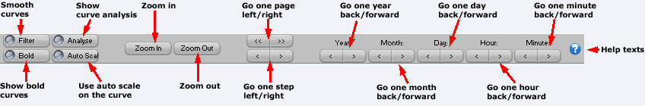
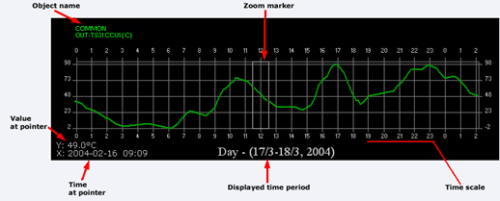

The green curve in the diagram is showing how the values have fluctuated during the period of time, which is indicated on the time-axis. You find the grading of the time-axis in the lower part of the diagram, with a raster-support at every grade. Below the diagram you also find the total period of time and the date.
On the left side of the diagram is the grading for measured values of the object. At the very lower left of the diagram you can read the value of the position of the mouse, followed by the unit of the value. This value can be practical to use as you can’t read an exact value by using only the raster-support.
In some cases you can also see a white rectangle in the diagram-window. This rectangle is used together with the zoom functions to change the period of time in the diagram.
For more information about zoom functions and other functions which are available with the keys above the diagram, see section Functions for Trend Curves, where You also find information about the function for showing several curves at the same time.

Trend Curves for single objects
To show the trend curves for a specific object you choose the key Trend curves which you find in the menu for objects. The menu will show up by clicking the key Menu in the information window for the specific object.
When this key is activated a new main window with a black diagram is shown. For more information about the diagram, see section Trend Curves.
In the upper part of the window for trend curves there are keys with functions for visualization and presentation of the trend curves

Functions for Trend Curves
In the upper part of the main window for trend curves there are keys to select the presentation.
The keys are divided into three groups. The group to the left is named Year, the group in the middle is named Zoom and the group to the right is named Move. The first two groups have two keys each and the group to the right has four keys. If a presentation of several objects at the same time in the diagram is chosen, there are also a list box and a key named Preferences to the right.
Below the three groups of keys there are four squares for marking named Auto Scale, Bold Curves, Filter Off and Analyze. With these functions the diagram and the curve can be manipulated to make the course of events more clear.
If the joint presentation of curves for different objects is chosen by the key Trend Curves in the speed bar at the very top of the window, there are also a list box and a key named Preferences. See section Joint Trend curves for more information.
The first group of keys to the far left named "Year" consists of two keys with the signs "+" and "-". With these keys you choose presentation of values of the object for the next or the previous year respectively. The selected year is shown within parentheses below the diagram.
The group in the middle named Zoom is also consisting of two keys named In and Out. By using these keys you can change the time scale in the diagram. You can zoom in – show a shorter period of time, or you can zoom out – show a longer period of time. The periods of time are preset on certain intervals, and every click on the in- or out-key make a change of one step in the respective direction.
The available periods of time for the time-axis are:
Period | Raster
1 year | Raster support at every month.
1 month | Raster support at 24 hours.
1 week | Raster support at 24 hours.
24 hours | Raster support at every hour.
1 hour | Raster support at every minute.
When using the zooming function you choose the period of time, which you want to zoom by applying the white rectangle over that period on the time-axis. To zoom another period you move the white rectangle to the wanted period by clicking the mouse on that period in the diagram. It is also possible to move the rectangle by pushing the mouse with the cursor inside the rectangle, and keep the button down and at the same time move the rectangle to the wanted position.
The group of keys to the right is named Move, and these keys make it possible to move the start- and stop-time for the period of time in the diagram in a simple way. The group consists of four keys marked with one or two arrows to the left and to the right. By clicking once on one of the keys with one arrow the diagram is moved one step in the wanted direction, keeping the scale of the raster-support. By clicking one of the keys with two arrows the diagram is moved one complete period of time in the wanted direction. The time or date, which is the last one, will appear in the beginning of the time-axis of the diagram if the right key with two arrows is clicked, and reversed for the left key.
The marking square Auto Scale is marked when the diagram automatically shall apply the scale for the y-axis, the axis for values, to cover the area between the highest and the lowest value. This makes it possible to study the fluctuation of the curve. If the marking square is not marked, the scale on the y-axis is applied to show the area between the highest and the lowest set points for the object, according to what is edited for the object.
The marking square Bold Curves doubles the thickness of the line of the curve. This function can be useful when doing a print out to make it easier to observe a particular curve, or to make a curve more visible when the resolution on the screen is high.
The marking square Filter Off is used to level the highest and lowest points of the curve and to soften it. This is used to make it easier to study the fluctuations and trends of the object. Please note that the algorithm for softening of curves only affects extreme tops and glens, which not can be classified as temporary. Curves, which have many short little spikes, are ignored, as softening of these spikes doesn't give any visible effect.
When clicking the marking square Analyze, the maximum-, minimum- and average-value will be marked in the diagram.

Picture editor
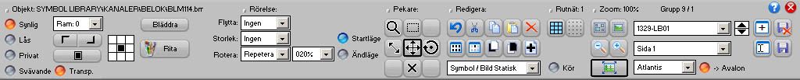

Display functions

The grid
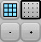
• Display grid: Activates / deactivates the grid display.
• Snap to: Snaps the objects against the grid.
• + / - : Increase / decrease the grid.

Zoom
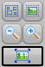
• You can select objects and zoom them in.
• Fit all objects into the display.
• Scale 1:1 : Resets the zoom factor to 1 (normal display).
• + / -: Increase / decrease the zoom.

Run / Real mode
• Run: You don't need to exit the editor to select the object dialog or test the picture. Just press this button and you’re in real mode, press again and you’re back in edit mode.

Object types
The editor has two kind of main object types:
Static: When an object is static it isn’t connected to any CCU-object, its only purpose is just for graphical presentation, for example a sensor symbol.
Dynamic: The object is connected to a CCU-object and behaves after that,
depending after the type you’ve chosen.

Text
Following types are available:
Static, Dynamic, Timeschedule, Goto Group, Shortcut to file, Run event.

Symbol / Picture
Following types are available:
Static, Dynamic, Timeschedule.
With Atlantis 5 a Symbol Library is automatically included on every session/edit.
You can build up a whole picture with this library or create your own library made up with bitmap pictures. Or you can paint on an ordinary bitmap background and don’t use the library at all. Usually, making a picture with the Symbol Library is much faster than drawing the whole “display scene” on a big bitmap.
It’s your own preferred taste how you want to edit the picture.

Figures
You have the following types:
Static: Line, Triangle, Rectangle & Circle.
Dynamic: Triangle, Rectangle & Circle.

Overlapped page
You can display other pages on the present page.
For example: If you want an overview of a couple of other pictures, you can put them all together to form a new picture just by selecting the desired pages and show them all at the same time.
See the overlapped page like a visual form of a Windows shortcut.

Object properties

Visibility
• Visible: Disable this if you want to hide something visual.
• Locked: You can lock an object so you don’t do the mistake of moving or resizing it. You can unlock it if just press once the object.
• Private: Object’s that are in private mode down get converted to the Avalon-CCU or the WEB.
• Floating: Use this function when you don’t want to get the object affected by the zooming factor or picture position. It always going to stay at the same position. This function is usually desirable when you have a menu system.

Frame & Color
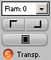
• Frame: The thickness of the frame.
• Colour 1: Colour on frame left/up.
• Colour 2: Colour on right/down.
• Background: The background colour. You can even change the background colour.
• Transparent: Transparent mode. On symbols you first must choose which colour will get transparent with the background colour.

Snap to / Align mode

• Select where the object will snap to the grid.

Object edit tools

The pointer
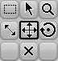
You can use the pointer tools on one or many selected objects at the same time.
Just press and drag on an empty region and you can select many objects.
Following modes are available:
• Select
• Zoom
• Size
• Move
• Rotate
• Delete

Edit
• Undo
• Cut
• Copy
• Paste
• Delete:
• Select All
• Inverse Selection
• Move To Front
• Move To Back
• New Object
With this button you create a new object by the selected list box that is close this button. You choose the object type by selecting from the list box and then pressing this button.

Special properties

Motion
The different motions are: Move, Size Rotate & Animate.
You use the following pointer tools to edit the specific motion
Size, Move & Rotate.

Types
Every motion has 4 types and one speed:
• Off: Disables the motion.
• Go To: This type is used if you for example have a circular meter and you want to show the value with a needle.
Or if you have a level sensor, then you can enable the move motion and select the different levels you want with Begin & End.
• Repeat: This type is often used if you want to animate something, for example a fan that rotates or an arrow direction.
• Cyclic: When you select this mode the motion goes back and forth.
For animation you must rename the bitmap symbols to: "xxx Frame 001", "xxx Frame 002", "xxx Frame 003"...
The editor then automatically enables this function.
Examples are included in the Symbol Library!

Page functions

Group / Page
• Group: Shows / selects the active group to edit.
• Page: Shows / selects the active page to edit.

Format
• Format: Here you can choose which format you want to edit in. The main picture is called Atlantis then you have the CCU's - Avalon 64 & Avalon 121.
• ->Avalon: This button enables you to only edit the Atlantis picture and then let the editor automatically convert the page into Avalon.

Archive
• New Page: Create a new page in the selected group.
• Delete: Deletes the selected group
• Rename: Renames the selected page.
• Save: Saves the selected page.

Keyboard commands
CTRL-Z: Undo.
CTRL-X: Cut.
CTRL-C: Copy.
CTRL-V: Paste.
CTRL-A: Select.
CTRL-D: De-select.
DELETE: Delete.
BACK: Delete.
F: Move objects in front
B: Move objects to back.
G: Grid.
S: Snap.
Left arrow: Move the objects to left.
Right arrow: Move the objects to right.
Up arrow: Move the objects up .
Down arrow: Move the objects down .
INSERT: Create a new object.
+ : Zoom in.
- : Zoom out.
/ : Smaller grid.
* : Bigger grid.
Q: Smaller grid.
W: Bigger grid.
PAGE UP: Change group.
PAGE DOWN: Change group.
ENTER: Enter Run mode / Real mode.
NUM-0: Exit Run mode / Real mode, return to Edit mode.
NUM-1: Zoom.
NUM-2: Select.
NUM-3: Tool 3.
NUM-4: Size.
NUM-5: Move.
NUM-6: Rotate.
NUM-7: Tool 7.
NUM-8: Delete.
NUM-9: Tool 9.
ESC: Exit the editor.

Files and folders
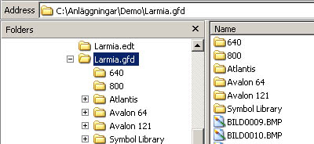
Following folders are used by the picture editor.
• LARMIA.GFD
The main picture folder. The files under this folder is there just for compatibility.
• LARMIA.GFD\ATLANTIS
The picture folder for the pictures sorted after the group number.
This is the edit folder when you edit the main picture.
• LARMIA.GFD\SYMBOL LIBRARY
The library for all the pictures.
• LARMIA.GFD\AVALON 64 & LARMIA.GFD\AVALON 121
The picture folder for the Avalon pictures.
This is the edit folder when you edit the Avalon CCU.
• LARMIA.GFD\640 & LARMIA.GFD\800
The files under those folders is there just for compatibility.
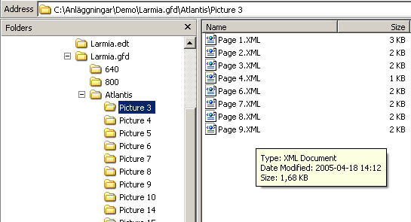
If you only use Atlantis 5 you only need to backup:
• LARMIA.GFD\ATLANTIS
• LARMIA.GFD\SYMBOL LIBRAY
• LARMIA.GFD\AVALON 64 (if you have Avalon 64 CCU’s)
• LARMIA.GFD\AVALON 121 (if you have Avalon 121 CCU’s)

Time Schedules

Time Schedules

Objects that have outputs can all have a time control. This is performed by a function called "Time Schedule". Time Schedules are separate objects, which have settings for On/Off at given times on different types of weekdays. An output can be completely controlled by the object "Time Schedule", and will then follow the condition of the Time Schedule. The Time Schedule can also be used within conditions and controls to get different regulation on different times for each weekday.
To set a Time Schedule with the times for On/Off for each weekday, You choose the key Time Schedule in the window which shows up when the key Menu has been chosen in the main key bar at the top of the window. A new main window is opened showing a Time Schedule with different weekdays and a row of keys with different functions for the Time Schedule. The functions in the key row are used to set the weekday, which shall be shown, and the time shift if any. More information about how to use the functions, you can find in section Functions for the Time Schedule.
To change the settings of a time schedule and information about how to read the time schedule, see section Editing of Time Schedules.
Otherwise the window is working in the same way as the standard for the Windows program. For further information see the manual for Windows.

Editing of Time Schedules
To be able to edit a Time Schedule the window for "Time Schedule" has to be visible. The window consists of a row of keys and a Time Schedule. To make the window for Time Schedules visible, you choose the key Time Schedule in the window, which shows up when the key Menu has been chosen in the main key bar at the top of the window.
The Time Schedule consists of different types of days to the left, followed by columns for setting of Start/Stop-times and to the right there is a key named Edit.
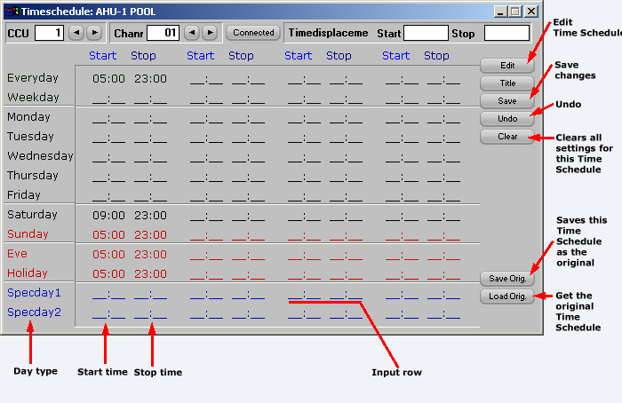
The list below shows all types of days which the system can handle.
Day type | Description
Everyday | Edited On/Off´s occur every day.
Weekday | Edited On/Off´s occur every weekday (working day).
Monday through Sunday | Edited On/Off´s occur every time it is a Monday, or a Tuesday etc.
Eve | Edited On/Off´s occur every Eve.
Holiday | Edited On/Off´s occur every holiday.
Special day 1 | Edited On/Off´s occur every special day 1 (according to definition).
Special day 2 | Edited On/Off´s occur every special day 2 (according to definition).
These types of days fetch its information from the calendar in the system, for more information about the calendar, see section Calendar. Eves and days, which are fixed as holidays are shown in red, letters and special days are shown in blue letters. The same colours are used in the calendar.
In the area for edited times all the times are shown which are edited for that Time Schedule, with lines which belong to every type of day. These lines are divided into four pairs of columns, each pair having space for one Start- and one Stop-setting. These four pairs of columns represent the maximum eight changes of the conditions in the Time Schedule within 24 hours. In every change of condition, which has an edited related time, the time is shown in hours and minutes separated by a colon. Where time is not edited, there is an underlining instead of hours and minutes.
The key to the right is chosen when you want to change the settings on the Time Schedule. When the key "Edit" is clicked, another four keys show up, one above and three below the "Edit"-key. When these four keys are visible, you can go on and change in the Time Schedule by clicking the time where the line for the type of day and the column for the change of condition are crossing. Instead of the indicated time a square for editing appears, and in that square You type the new time for the change of the condition. This procedure has to be repeated until all new settings in the Time Schedule are done, and after that You choose the key Save to the right, and the Time Schedule is saved.
You can also regret the change and go back to the setting last saved and visible when You clicked the key Time Schedule, by clicking the key Undo, which is situated below Save.
To erase all the settings in the Time Schedule in a quicker way than erasing each setting, You can click the key Reset at the bottom of the additional keys to the right. By doing this, all settings in the Time Schedule in question are erased. Other Time Schedules are not concerned.
If You want to change the title of the Time Schedule, You click the key Title at the top of the keys to the right, and a new window shows up, where You can edit the title. When any change is performed, the CCU has to be restarted, see section Loading of the program to the CCU.
To set the Time Schedule which You want to present and information about the functions of the keys at the top of the window for Time Schedule , see section Functions for the Time Schedule.

Functions for the Time Schedule
The keys and the functions at the top of the window for the Time Schedule are used for choosing the Time Schedule to be shown and time shift if any. The functions are divided into various sections. The section to the left concerns the chosen CCU/PC, the next section concerns the number of the Time Schedule and the section to the right concerns time shift. In the middle there is also a key for listing of the objects connected to the CCU/PC.
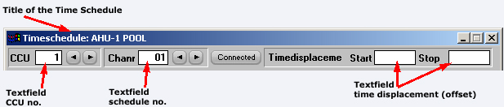
The section to the left consists of two keys and an editing field to the left of these keys. In the editing field you can see the number of the CCU, where the editing of the Time Schedule is saved. The objects, which shall be controlled by the Time Schedule, must belong to the same CCU as the Time Schedule, but you can also save the Time Schedule in the SCADA. In that case you type "PC" in the editing field instead of the number of the CCU. The result of this will be that all objects in all CCU´s connected to the SCADA can use the Time Schedule, but if the communication disappears the CCU´s looses the control by the Time Schedule. Please observe that to save in a CCU only works for CCU-numbers connected with CCU´s from Larmia Control.
To change a CCU-number You click with the mouse on the editing field and type the wanted number of the CCU or "PC" followed by pushing the key Return. You can also step-by-step reach a CCU-number by clicking the key "+" for a higher number and the key "-" for a lower number.
The next section consists also of two keys with an editing field to the left. With these you choose which Time Schedule shall be shown. To change the number of a Time Schedule you click with the mouse on the editing field and type the wanted number of the Time Schedule followed by pushing the key Return. You can also step-by-step reach a number of a Time Schedule by clicking the key "+" for a higher number and the key "-" for a lower number. At the same time as the number of the Time Schedule is changed also the title of the window is changed to the matching one.
By clicking the key Obj.list in the middle, a new window will show up on the screen listing all objects connected to the CCU/PC in question.
The section to the right consists of two editing fields for setting of time shift if any. The left one shifts all Start-settings and the right one shifts all Stop-settings of the Time Schedule. The time shift is indicated by clicking with the mouse on one of the editing fields and typing of the number of minutes, which the Start- or Stop-setting shall be delayed or changed to an earlier time. A positive figure delays the change of the condition and a negative figure moves the change of the condition to an earlier time. The time shift is mostly used in connection with system functions, as any system function can be indicated in the Time Schedule. This results in that the time shift can be controlled by objects or conditions, which move the Time Schedule a certain time in a certain wanted direction depending on the conditions. It is important to know that if the time shift is changed after a change of the condition, the change of the condition will not be changed again. The reason for this is to avoid unnecessary Start/Stop´s to be generated as the conditions might change when changing the Time Schedule.

Calendar

To get a general view of the days of the year, when a festival falls and on which day of the week a certain date falls, there is a calendar in the system. The calendar will be shown by clicking the key Calendar in the window, which shows up when the key Menu has been chosen in the main key bar at the top of the window. Now you can see a new main window showing the days of the week and a key bar at the top.
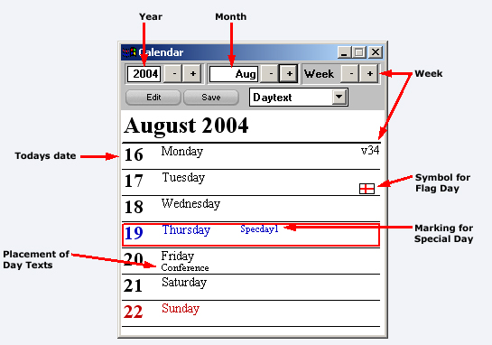
The calendar itself shows information about the days in the present week starting from Monday. The present month and year are shown above the days. The information shown is the date, the day of the week and the number of the week at the top to the right. Weekdays and the day before holiday are shown in black and holidays in red. The date of today is surrounded by a red rectangle.
At the top of the window of the calendar there are three groups of keys with two keys in each group and a field for editing in two of them. On the next row to the left there is a key Edit. With the group to the left you choose the year, which you want the calendar to show. With the two keys marked "-" and "+" You can step one year backward or one year forward from the visible year. The same year, which is shown in the calendar, is also shown in the editing field to the left in the group. In that field you can also type by yourself which year you want to be shown in the calendar.
The next group in the middle you can use to choose which month to be shown in the calendar. With the two keys "-" and "+" You can step one month backward or one month forward from the visible month. The same month, which is shown in the calendar, is also shown in the editing field to the left in the group. In that field you can also type by yourself which month you want to be shown in the calendar.

With the third group you can choose which week to be shown in the calendar. The two keys "-" and "+" are used for stepping one week backward or one week forward from the visible week. The number of the week you can see to the upper right in the calendar. There is no editing field for the weeks, and you can’t type any number of a week by yourself.
The key Edit in the row below is used for adapting the calendar to a specific plant. The function makes it possible to make deviations from the preset normal holidays, and also to add special days applicable to the specific plant. These special days are used by the time channels, which are adapting the information if there is any edited.
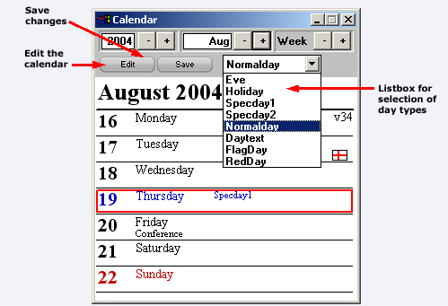
When choosing the key Edit another two functions appear in the row. The key is named Save and there is also a list box. To change the type of a weekday on a specific date, you choose the type of the day in the list box, where all types of days are listed. The types of days are:
Day type | Description
Eve | Eve has an own schedule for time channels.
Holiday | Holiday has an own schedule for time channels.
Special day 1 | Own defined special day, has an own schedule for time channels.
Special day 2 | Own defined special day, has an own schedule for time channels.
Normal day | Normal weekday has an own schedule for time channels.
Red day | Eve or holiday, but is connected as a Normal weekday in time channels.
Day text | Extra text can be added for the day.
Flag day | Adds a flag to the date.
Special days are used for own defined days, when the time channels are not following the normal day case for example the day before Christmas Eve or vacation days.

When you have chosen the type of day in the list box, you use the mouse to point out the day, which you want to change, and when clicking this day it is changed. This procedure has to be repeated until the calendar is applicable to your situation. After that you click the key Save to save the modified settings for the calendar or choose another function to regret and no changes will be saved. When changes have been done, the CCU has to be reloaded, see section Loading of the program to the CCU.

Editing

Edit (plant configuration)

With this key function a new programme is started to edit and to make the configuration of the system. To edit the system means to create and change groups and objects in such a way that the system is presented as clear as possible, and to give the groups and objects suitable names. Here you decide the type of the object, the address of the object and to which group the objects belong. The control and regulation of the object are also decided here, as well as conditions, controllers and connections between objects. To configure the system means to set joint functions of the objects in a proper way.
All these functions are performed in another programme, where the configuration is the same as in an operation program of the operative system DOS. The difference from that operation program is that this editing program has no communication with external units and CCU´s, and that certain functions in the programme have no effect. There are certain functions, which are disconnected, and other functions, which don’t have any influence on the settings. Below You can find a description of the functions which should not be used, and after that a description how to find the permitted settings. When the function is found You can find help for the settings and effects of the functions in Enclosure 1, which is an extract of the manual for the operation program in DOS. The handling of the editing program is the same as for the operation program in DOS.
Please observe that the Windows NT operation program is working in the background, which means that if there are any alarms they will be printed out on the printer and sent via a modem for instance to Minicall.
When you choose the key Edit the program is started and is covering the whole window, and the main menu for the programme is shown. In the upper part of the window you can find a row of keys, and to the right of the keys there are information about type of system, date and time. The menu itself is brown and consists of seven sections. In each section there are functions to choose between, and at last there is a function named "To operation". If the mouse clicks this function the editing program is finalized and you return to the operation program in Windows NT. The sections consist of the following functions:
SYSNO: | Here You will find help-texts for system numbers, see also section System number (SYSNO).
SYSTEM FUNCTIONS: | Here You will find help-texts for system functions, see also section System Functions.
CONDITIONS: | Here You will find settings for conditions in the system, see also section Conditions.
CONTROLLERS: | Here You will find settings for the controllers in the system, see also section Regulators.
CCU CONNECTIONS: | Shows a picture of the CCU´s in the system, how they are connected and which modules they consist of.
SYSTEM EDITING: | Here You will find functions for editing of the system, adding and changing of texts, names, objects and groups and setting of all connections within the system.
TO OPERATION: | Return to the operation program in Windows.
The key row at the top has also certain functions, which can be clicked for using as follows:
LOG IN: | No effect.
ALARM: | No effect.
MENU: | Shows the main menu for the editing program.
EVENT LIST: | No effect.
TREND CURVES: | No effect.
SELECT GROUP: | No effect.
MODE: PICTURE/TEXT: | No effect.
LATEST CHOICE: | No effect.
LARMIA CONTROL LOGO: | Shows the information window for the system.
TIME AND DATE: | Should not be chosen as it has only temporary effect.
These are the functions, which are available and can be chosen. Below You will find a description of the most common applications of the editing program, for other functions see Enclosure 1.
Editing of the system: | Go to the main menu by choosing the key Menu in the key row at the top. When You choose System Editing these function will appear. For further information see the help in Enclosure 1.
Editing of conditions: | Go to the main menu by choosing the key Menu in the key row at the top. When You choose Conditions, the window for editing of conditions will show up. For further information see the help in Enclosure 1.
Editing of controllers: | Go to the main menu by choosing the key Menu in the key row at the top. When You choose Controllers, the window for editing of controllers appears. For further information see the help in Enclosure 1.
Showing of CCU´s: | Go to the main menu by choosing the key Menu in the key row at the top. When You choose CCU Connections, the window for showing of the CCU´s and their connections appears. For further information see the help in Enclosure 1.
Please note that when there is a change in the editing, the system has to be restarted, otherwise the operation program in Windows will not take notice of the change. The restart should be done as soon as possible after the change of the editing. Restart of the program is done by pushing the "CTRL-ALT-DEL" keys and then You choose finish with restart. The push button key "Restart of the System", which is in the editing mode is only used when new editions shall be loaded,. This restart is not needed for changes.

Conditions (logic functions)
Control and regulation of objects can be done in different ways. Normally the control of an object is depending on different other factors which are connected in a unique way for the specific object. These factors can be the value of other objects in the system, time factors or a combination of these. To combine these factors in a certain way to obtain a special character of a new factor is called to put conditions together. A condition is calculating its specific value by putting other values together in a specific way. This condition can then be directly connected to objects for control and regulation, and also be used for other functions to control periphery equipment and the system as a whole.
In the operation program for Windows the editing and the connecting of these conditions are to be find in a program under the function Edit, and is called Conditions. This function is selected by clicking the key Edit at the top of the key bar for the operation program. Then a new program is starting where the function for connecting and editing of conditions can be found.

Loading of the program to the CCU

All CCU's manufactured by Larmia Control, which have communication with the SCADA, can load its edition from the SCADA. To load the edition means that every CCU in operation will have a unique profile of its own regarding the objects belonging to it and their connections to the CCU, and also how the control and regulation shall be performed. That profile is different from CCU to CCU and is not stored permanently but temporary to make it easy to change. The profile is distributed to the CCU´s in such a way that they are able to control and regulate also when there is no connection to the SCADA.
Changes are not only concerning names and distinctions but also regarding control and relation of the objects and management of the CCU. The uniqe profile is called the edition of the CCU. To execute a change in the CCU, the change has to be transferred to the CCU, which is done by the action called Send Edit to CCU.
To load a new edition to a CCU after a change has been done, you choose the key Load Edit in the window with keys which shows up when the key Menu in the main key bar at the top of the window has been clicked. A new window is shown with functions for loading a CCU from the SCADA.
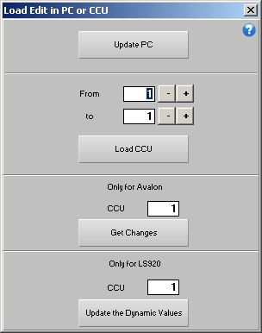
This window require that You know in advance in which CCU's changes have been done, as the identification-numbers of the CCU's are used. For more information about the identification-number for a CCU, see section What is a CCU?
When the identification-numbers for the CCU's are known, the lowest number is typed in the upper field with the text From and incl. CCU No., and in the lower field with the text To and incl. CCU No. the highest number of the CCU's which shall be loaded shall be typed. To choose the identification-number you can place the marker in the editing field and type the wanted number. You can also step-by-step reach the number with the keys "-" "+" to the right of the editing field.
When the appropriate CCU's are chosen, you click the Send Edit to CCU key in the window or the Return-key on the keyboard, and the changes are automatically sent to the respective CCU. The CCU will then be restarted with the new edition, and the window for loading the edition disappears.
The loading of the edition to the CCU can be stopped by clicking the key Cancel in the window or by closing the window using the Window-menu at the very top of the window to the left. This doesn't mean that the performed changes in the SCADA are cancelled, but sending of new edition to the CCU will not be executed. The changes remains and can be transmitted later.
Please note that loading of a CCU only works together with the Larmia Control LS920.

Misc.

To start and to quit
In the operation program of Larmia Control You distinguish between a server part and a client part. The program, which acts as a server part is called LCServer. The assignment of this programme is to execute all tasks in the system, as communication with the CCU's, print-outs, handling of alarms, loggings etc., and is the driving member of the system. The user can’t influence this program, and therefore it can be integrated into Windows as a service.
The client part of the operation program is called LCClient.exe, and is the part, which presents all data and information, and makes it possible to change the settings in an easy and understandable way for the user. All the information is picked up from the server part, and therefore it can't work by its own but must be able to communicate with the server part. If only the client part is started, it will automatically be closed after five seconds.
Both these programs are started by running its .exe file, either from an icon in the program manager or from the file manager in Windows.
The client part can also be started via the network, where switches are used to state where the client program shall search for files for editing and graphics and status and events in the system. The switches shall be formed according to the following syntax:
LCClient.exe [computer name] [share name] [computer name] [share name]
Where the first group of computer and share name is stating where the client program shall pick up status and events in the system, and the other group is stating where to pick up files for editing and graphics. Below is an example of start up via the network for the client program, where editing and pictures are available in a catalog shared as "Larmia" locally on a computer named "Portable-computer", and where a computer named "Larmia-central" with the share name "Larmia" runs the server program:
LCClient.exe Larmia-central Larmia Portable-computer Larmia
Another function, which can be used when starting up of the client, is automatic log in. By stating the switch "/p" directly followed by a password for the level where You want to log in, the client program is started at that level. An example of automatic log in is:
LCClient.exe /pvolvo
(Logs in at level 2 if the password isn't changed).
The standard Windows window handling functions are used for minimizing, maximizing, restoring and exiting the program.

Configuration
By configuring a system means to set common functions of presentation for the operation program, and to state certain connections to peripheral units. It includes also setting the measures to be taken when there is an alarm or a fault.

The Control Panel

Windows includes a program called "The Control Panel", where You do the settings for Windows NT and belonging programmes. Here you can design your desk, the configuration of the network etc. This programme is also used for making the settings for the operation program. You can set the telephone-numbers for Minicall, functions for the printer, presentation of alarms etc.
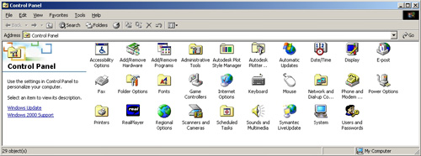
The control panel will be reached by clicking the key Control Panel in the window, which shows up when the key Menu has been chosen in the main keybar at the top of the window. Each part of the Window NT, which is set here, will have an icon in the window of the control panel.
To start any icon in the control panel, the icon for the part of the system, which shall be changed, shall be marked, and You can push either the key "Return" on the keyboard or make a double-click with the mouse on the icon.

Regulators
Controlling of analogue objects differs from controlling of digital objects as digital objects only have two positions of status, but an analogue object can have any value between given limits. Because of that analogue objects are normally controlled by regulators, which are capable of continuous control and regulation of the object to the most appropriate value according to set factors. These factors can in the same way as for conditions be other objects, time schedules and combinations of these. The regulator uses the values of these given factors, adapts the regulation according to that and executes the suitable regulation after certain time intervals.
In the operation program for Windows the edit and connections of these regulations are available in a program called Regulators under the function Edit. This function is selected by clicking the key Edit to the upper right in the key bar for the operation program. Then a new program starts where the function for connecting and editing of regulators are. See also the section Edit for more information about how to find the function for creates, change and connect regulators to objects.

Notes

There are three types of notes. There are notes valid for the whole system, for instance information to other people regarding editions, time for testing of the system, visits etc. There are also notes concerning single groups, with information regarding the whole group or all the objects in the group for instance concerning rebuilding, changes of connections between objects, time for changes or maintenance. At last there are also notes for the single object, where information regarding service and maintenance, intervals, spare parts and reports about faults can be noted.
All these notes can be reached from a key in the menu function of each category, for the system, for the group and for the object. For the system You can find the menu at the top among the main keys, for the group You can find the menu at the top to the left in the group window and for the object You can find the menu in the information window of the object.
When clicking the key named Notes a simple program with a text editor will start, where you can read, add and change the text if there is any. To go back to the operation-program, the text editor has to be finished.
The text editor has a help-function included for the functions in the program, where you can find more information.

The Calculator

Windows includes a program called "Calculator", a program which looks like and works as a mini calculator. There you can find help not only to make elementary mathematic calculations with the four rules of arithmetic but also help to solve more advanced complicated mathematic problems.
To start the calculator You choose the key "Calculator" in the window with keys which shows up when the key "Menu" in the main key bar at the top of the window has been clicked.
The calculator-program has a help function included, which is referred to for further information about how to use the program.

Last choice

With this key function the last chosen group or function will return to the window. Functions, which can be returned, are the ones, which cover a new main window, as alarm list, list of events and Trend Curves.

Help texts

With this key function you can reach the help available in the program in a simple way. The help text starts with the main list of contents. The content is the same as in the documentation for the LS 9000-system, but in the help text it is easier to jump from one information to another, and you can look for single words.

Larmia Control

When using this key function an information-window will show up where you can find the version number of the programme and the telephone number to the manufacturer

Window handling
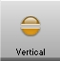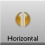
These three keys include functions to arrange the main window of the programme, to show various windows at the same time and to adjust the appearance according to the size of the screen.
The key to the left with a blue plus sign generates a new window without removing the existing one. At the same time the windows on the screen will automatically be arranged in such a way that all of them are visible.
The key in the middle arranges all the windows above each other, and the key to the right arranges all the windows beside each other.
To close a window the key at the very top to the very left of the window is used. You can either click that key once or click "Close" in the menu, which will open, or you just double-click the key.

Time and date
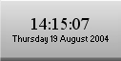
There is a system clock, which shows the present time and date. Time and date can be adjusted as normal in "Date/Time", which you find in the Control Panel.

